OLSK Acorns Breakfast & After School Club
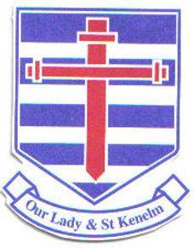


Catering for all children aged 3-11 years old

Providing wraparound care for children Monday to Friday during term time only. We offer a wide variety of activities celebrating festivals and certain dates to remember. Children are also encouraged to input their own activity ideas and topics. Please take a look at our facebook page @OLSK ACORNS to see all of the fun things we get up to.

Our opening times

Breakfast Club
7.30am until drop off at school classrooms

After School Club
3.15pm - 5.50pm

Our Fees
Breakfast Club - £5.00 per session

Children are offered a variety for Breakfast such as pastries, cereal, toast, fruit and yoghurts. They also have access to activities, games and toys throughout the session.

After School Club - £10.25 per session
£8.75 sibling rate

Throughout this session, children are encouraged to take part in a focus activity and have a wide variety of daily provision to choose from all linked into the EYFS. There is also a healthy snack option of toast, sandwiches, crackers, fruit, vegetables and yoghurts.

For more information please contact the Manager Emma on 07955 183287 or email olskacorns@outlook.com

